- Tick the bigger :

2. Tick the shorter:

3. Tick the same object:

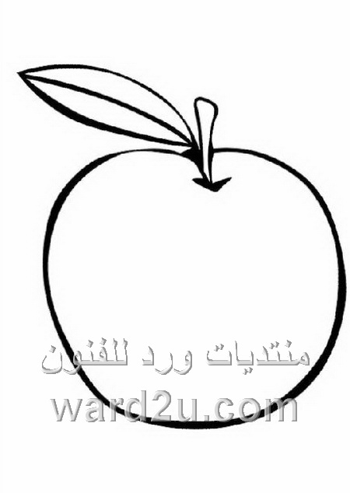
4. Colour the same size:
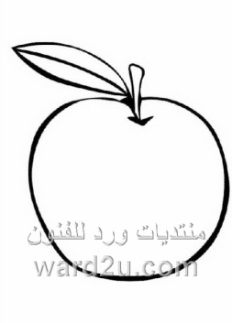
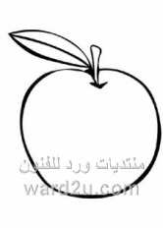

5. Tick the shapes that have parts of the same size and the same
Shape:

6. Complete the pattern:

7. Circle the star above:

8. Look and circle:
Direction of the arrow to the:

Right Left Right Left

9. Circle the smaller number:
8 5
1 2
2 3

12 18

10. Circle the greater number:
16 5
11 7
4 6
3 4

11. Write:
5 7
3 6
2 4

12. Choose the correct option. Mark your answer:
 | 3 | 5 | 8
 | 8 | 2 | 7
 | 2 | 6 | 10
 | 3 | 12 | 9

13. Write:
13 18
15 19
14 12
20 11
16 17

14. Count and write the number:

15. Write the number that comes before:
8

6

16. Write the number that comes before:
2
7

9

12

15
18

17. Write the number that comes next:
9
6

18. Write the number that comes between:
2 |  | 4
5 |  | 7

8 |  | 10
12 |  | 14

17 |  | 19
14 |  | 16

11 |  | 13

19. Arrange the numbers in ascending order:
3
2
1
5
4
6

12
17
13
9
10
8

1
19
20
14
3
16

20. Arrange the following on number line:
14
3
17
6
10
2
8
5
12
18
16
20
13
4
11
1
9
7

21. Arrange the numbers in descending order:
14
3
16
9
10
8
3
2
1
5
4
6

1
19
20
12
17
13

22. Arrange the following on the number line:
5
8
12
13
10
6
1
5
7
18
16
20
7
4
14
3
9
11

