 | Pairs number | One of pair
1.

2.Count using the number line in ascending order , count by 1 s each time.

0 1 2 3 4 5 6 7 8 9 10

3. Count using the number line in descending order count by 2s each time:
0 1 2 3 4 5 6 7 8 9 10

4.Count then colour:

Fourth

Eighth
first

5. Find the sum :
+ =

+ =

6.Addition on a number line :
3 + 4 = 0 1 2 3 4 5 6 7 8 9

2 + 7 =
0 1 2 3 4 5 6 7 8 9

7.Find the sum :
3
+ 2

4
+ 3

8.Write the correct number in the box :
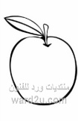  1 + = 5 | 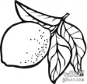  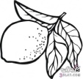  + 3 = 6


9.Finde the remainder :
4 - 3 =
2 - 1 =

10.Use the number line to find the remainder :
_ =
0 1 2 3 4 5 6 7 8 9

_ =
0 1 2 3 4 5 6 7 8 9

11.Find the difference :

_

_

12.Complete by tens :
 |  |  | 40 |  |  |  |  | 90

13. How many tens :
40 = tens 70 = tens 90 = tens

14. Adding one digit numbers :
7 + 2 = 8 + 5 = 3 + 9 = 4 + 2 =

7 4
+ 6 + + 2 + 9
8 12 10

15. Adding two digit numbers :
Tens | units
2  + 5 | 3  4
Tens | units
6  + 1 | 2  3
Tens | units
7  + 2 | 4  5

16. Illustrate on the number line :

16+7= 15 16 17 18 19 20 21 22 23 24 25

22+ 8=
20 21 22 23 24 25 26 27 28 29 30 31 32

25+6= 20 21 22 23 24 25 26 27 28 29 30 31 32

17.Subtracting one digit numbers :

13 _ 5 =

17 _ 5 =

18. Subtracting two digit numbers :
8 9
3 6 _

5 5
2 8 _

19. Use the number line to find the difference :
12-7=
5 6 7 8 9 10 11 12 13 14 15

22 - = 11
11 12 13 14 15 16 17 18 19 20 21 22

20.Illustrat on the number line :
33 _ 12 = 21
12 13 14 15 16 17 18 19 20 21 22 23 24 25 26 27 28 29 30 31 32 33

28 _ 18 = 10

10 11 12 13 14 15 16 17 18 19 20 21 22 23 24 25 26 27 28 29 30 31

21.Complete :

4 tens and 8 units
Fourty eight
22.Circle the digital clock that shows the same time :
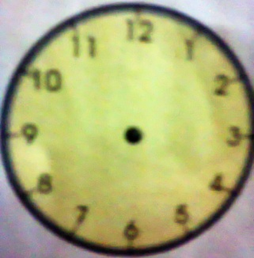
12:00 03:30
12:15 03:00
12:30 03:45
12:45 03:15

23. Draw the hour hand and minute hand to match digital clock :

01:45 06:30 10 :10

24. Circle the right answer :
- The day that comes before Friday is:
Thursday Monday Wednesday

- The day that comes after Sunday is ;
Monday Friday Tuesday

- The day that comes between Tuesday and Thursday is:
Saturday Wednesday Monday

