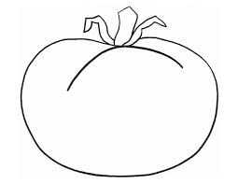
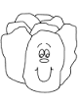
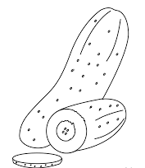
*Q1:Name the vegetables then colour them:

*Q2:Write the parts of the tree .
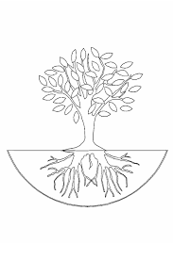

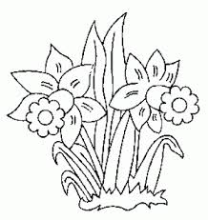
*Q3:Name the flowers. then Colour them:
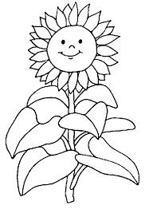
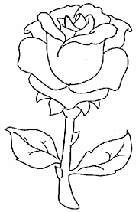

*Q4:Write the parts of a flower:

*Q5:Match:
Name of plant Leaf shape
Palm Heart-shaped
Olive Needle-shaped
Banana Feather-shaped
Pine Lance-shaped
Lotus Tooth-shaped

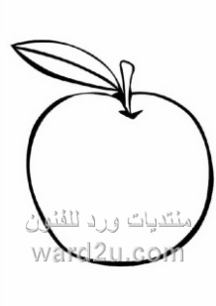
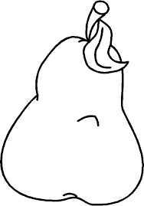
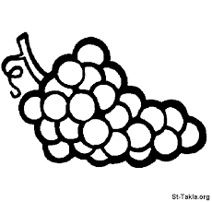
*Q6:Write the name of fruits. Then colour them :
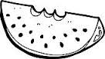

*Q7:Complete. from the words in the box:
Seeds _ many _ size_ shapes _soil _grow _water _sunlight

-The fruits contain ……….. .
-Some fruits have ……… seeds .
-Seeds have different …………. And ………… .
-New plants ……..from seeds .
-Seeds need ……….. , ………… and ………… to grow.

*Q8:Match:
Animals Animal habitat
Dog Desert
Fish Burrow
Mouse Stable
Horse Aquarium
Camel Kennel

*Q9:Complete:
Jungle - Pet animal - farm - sea – desert

_ ………. Live with us in our homes .
_Farm animals live in the ………. .
_Wild animals live in the ……….. .
_Desert animals live in the ……….. .
_............. animals live in the water.

*Q10:Name the animals then colour them:
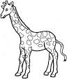
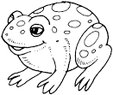
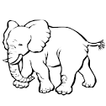

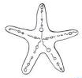
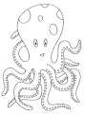
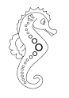

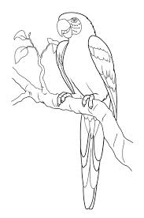
*Q11:Match:
Falcon

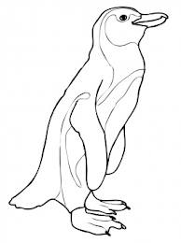
Parrot

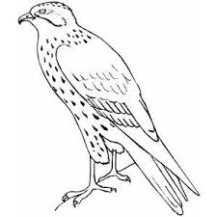
Bat

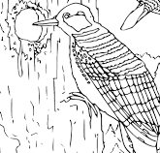
Penguin

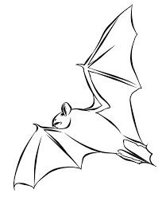
Owl

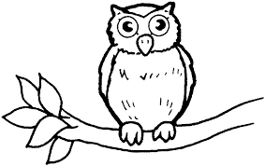
Woodpecker

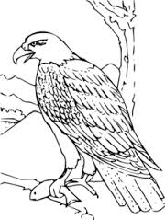
Eagle

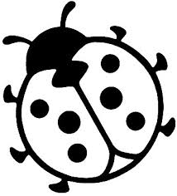
*Q12: Circle the correct answer:
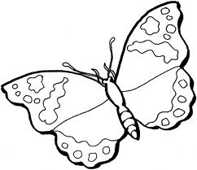
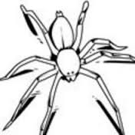

Fly _ Crawl Fly _ Crawl Fly _ Crawl
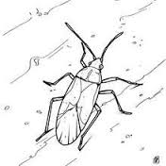
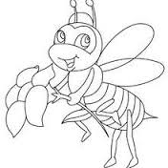
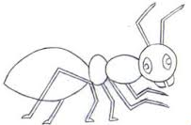

Fly _ Crawl Fly _ Crawl Fly _ Crawl
*Q13:Match:
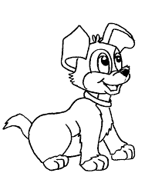
Animals Animals young


