*Q1:Match:
Animal Sounds
Lion Croaks
Honey bee Hisses
Horse Roars
Donkey Neighs
Snake Buzzes
Frog Bellows
Cow Brays

*Q2:Complete:
Feathers – Scale -Woman -Fur - man -_Puppy -Seeds

-Animals may be covered with ………. , ……….. or …………. .
-A baby girl grows into a …………. .
-A baby boy grows into a ………….. .
-Small ……….. grow into large trees.
-A ………. Grows into a dog .

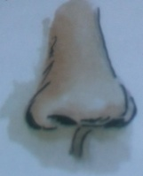
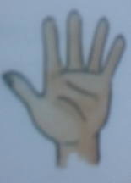
*Q3:write the name of senses:
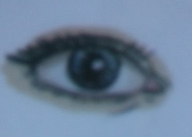

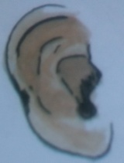
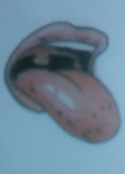

*Q4:Name the light sources in the picture:
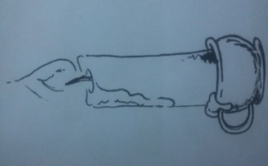
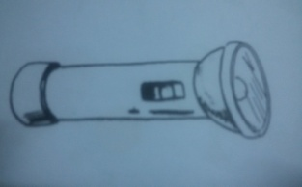

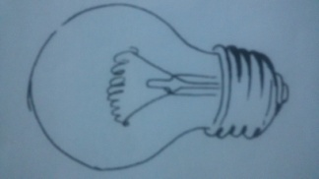

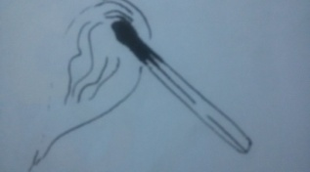
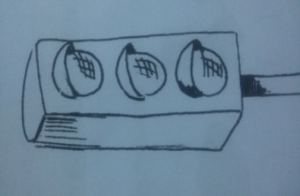

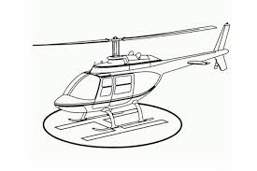
*Q5:Match:
Aero plane

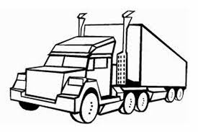
Train


Helicopter

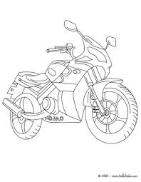
Truck

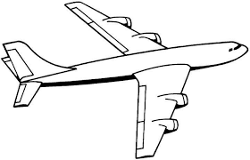
Ship

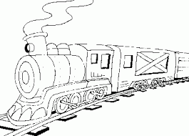
Motorcycle

*Q6:Complete:
Sea – stove – heavy –cold drinks – fan - warm

-In a hot day:
We use a …….. ,we drink ………… and we go to the ……..
-In a cold day :
We use the …….., we ……… ourselves .
and we wear ………… clothes .
*Q7:Match:
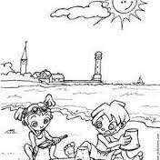
Seasons picture
Spring

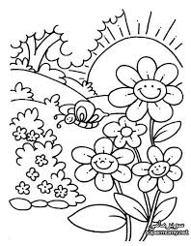
Winter

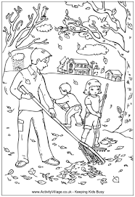
Summer

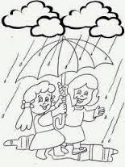
Autumn

*Q8:What kind of weather is this ?
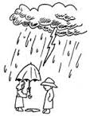



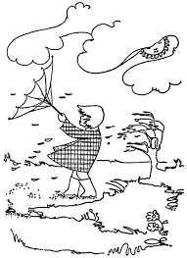

*Q9:Complete:
Wind – air – feel -see

-There is …… all around us.
-We can not ……… air. but we can …….. it when it is moving.
-Air that moves quickly is called …………. .

*Q10: Circle the correct answer :
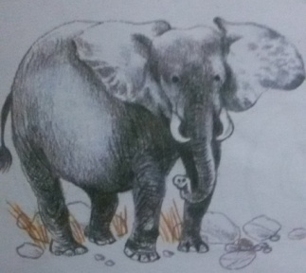
Heavy or Light

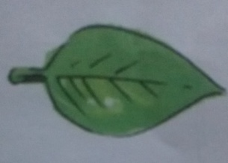
Heavy or Light
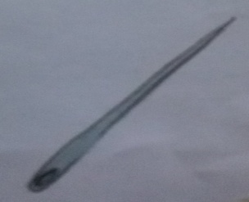

Heavy or Light
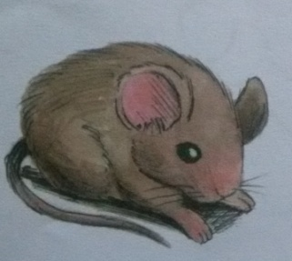

Heavy or Light
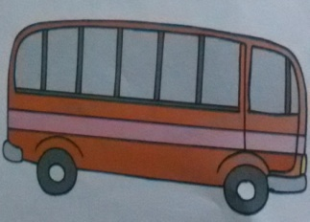
Heavy or Light


Heavy or Light
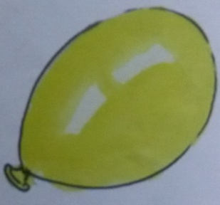

Heavy or Light

