*Q1:Complete:
Not alive -move -themselves- alive – do not- living - drink

-We are ………… .
-Living things grow , ………, eat ,…..….and sleep.
-Non-living things …………. Grow and breathe.
-Many things around us are …………………
-plants and animals are ………… things.
-A car and an aero plane can not move by ……………
*Q2:Name non-living things around you:
1-……..... 2-…………..
3-………. 4-…………..
*Q3:Name the parts of body
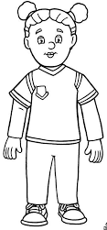

*Q4:Fill in the blank :
Eyes – feel – machine – hear – nose - taste

-Our body is like a ………. .
- We see things with our ……….
-We ……… things with our ears .
-We ……… things with our skin.
-We smell things with our ………… .
-We ………. Things with our tongue.
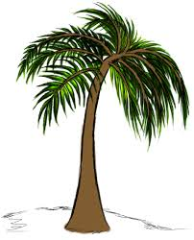
*Q5:Match:

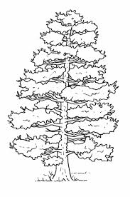
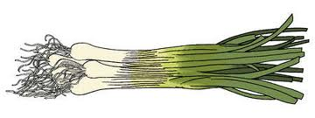
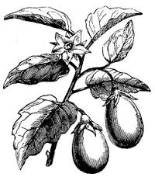
Pine

Palm

Eggplant

Scallions

*Q6:Complete:
Climbers – surface – trees – little – hills

-Some plants are very tall and strong called ……….
-Some plants can not stand straight such plants called ….......
-Some plants grow on the ……….. of water.
-Some plants can grow in places where there is very …….. water.
-Some plants grow only on ………. .
*Q7:Can you tell the name of these leaves?
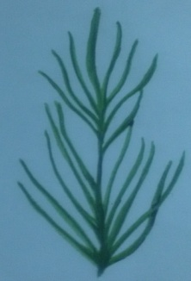
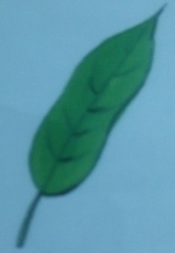
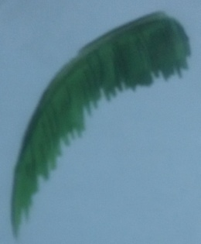

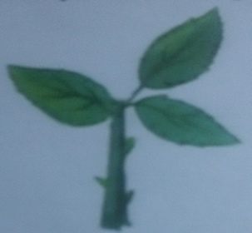
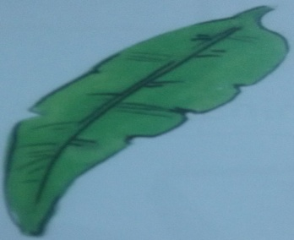
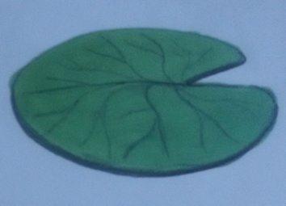

*Q8:match:
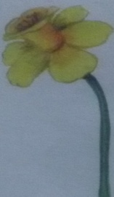
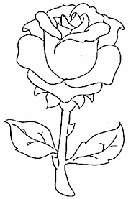
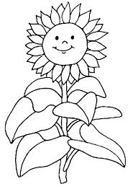
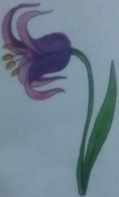
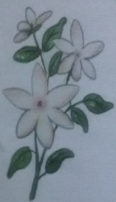
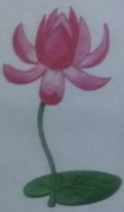

Rose

Lotus

Jasmine

China rose

Tulip

Sunflower

*Q9:Put √ for true and x for false:
-Animals do not need food and water every day ( )
-Some animals live in jungles( )
-Animals have different shapes and sizes ( )
-Animals are non-living things ( )
-Some animals live with us in our homes ( )
-Pets and farm animals are wild animals ( )
-Animal are very useful to us ( )
****************************************************
*Q10:Complete:
Various–plants–grind–energy–animals–bread–buffaloes–growing-germs

-We eat ………. Kind of foods.
- Food gives us ……… to work and play.
-We get food from ………… and ……….. .
- Wheat flour is used to make ……….. and cake.
-We ……… wheat seeds to make wheat flour.
-We can drink milk from cow , ……… and goats.
-Milk is very good for ……….. children .
-Spoil food contains ……….It can make us sick.
*Q11: Put √ for true and x for false:
-A plant grows to become a tree ( )
-Baby animals grows to become a big animal ( )
-All children are strong and healthy ( )
-We do not need clean air to breathe ( )
-Flies and dust make food clean ( )
-Dirty food can make us ill( )
-Dirty water is good for our health.( )
-A dirty body is not good for your healthy.( )
-Our body needs sufficient sleep to function properly ( )
*Q12:Which of these things do you need to stay alive .circle the correct answer:


